**Spring Boot Actuator**

**Problem**:

1. How can I monitor and manage my application?
2. How can I check the application health?
3. How can I access application metrics?

The solution is Spring boot actuator.

**Solution: Spring Boot Actuator**:

1. Exposes endpoints to monitor and manage our application
2. We easily get DevOps functionality out-of-the-box
3. Simply add the dependency to our POM file
4. REST endpoints are automatically added to our application

No need to write additional code. We get new REST endpoints free.

**Spring Boot Actuator**:

Spring Boot provides actuator to monitor and manage our application. Actuator is a tool which has HTTP endpoints. when application is pushed to production, you can choose to manage and monitor your application using HTTP endpoints.

To get production-ready features, we should use spring-boot-actuator module. We can enable this feature by adding it to the pom.xml file.

<!-- Add Support for spring boot Actuator -->

<dependency>

<groupId>org.springframework.boot</groupId>

<artifactId>spring-boot-starter-actuator</artifactId>

</dependency>

* Automatically exposes endpoints for metrics out-of-the-box
* Endpoints are prefixed with: /actuator

Here some of the endpoints that we can use

|  |  |
| --- | --- |
| **Name** | **Description** |
| /health | Health information about your application |
| /info | Information about your project |
| … | … |

**Health Endpoint**:

* /health checks the status of your application
* Normally used by monitoring apps to see if your app is up or down

Here is the screen share of our given application.

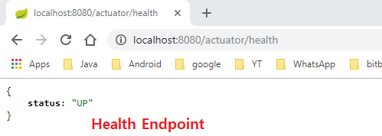

The health status is customizable based on our own custom business logic.

**Info Endpoint**:

* /info gives information about your application
* Default is empty

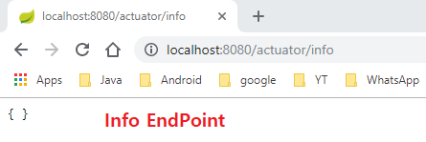

Here by default the **/info** endpoint is empty because we don’t add any value in our " **application.properties** " file. Now add some value in " **application.properties** " file.

**application.properties**:

info.app.name=My Super Cool App

info.app.description = A crazy and fun app, yoohoo!

info.app.version = 1.0.0

Now we will get the info.

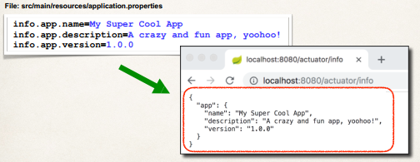

**Spring Boot Actuator Endpoints**:

* There are 19+ Spring Boot Actuator

|  |  |
| --- | --- |
| **Name** | **Description** |
| /auditevents | Exposes audit events information for the current application. |
| /beans | Displays a complete list of all the Spring beans in our application. |
| /mappings | Displays a collated list of all **@RequestMapping** paths. |
| … | … |

**Full List of Actuator Endpoints**:

<https://docs.spring.io/spring-boot/docs/current/reference/htmlsingle/#production-ready-endpoints>

**Exposing Endpoints**:

* By default, only /health and /info are exposed
* To expose all actuator endpoints over HTTP, add the following code

**File: src/main/resources/application.properties**:

# Use wildcard "*" to expose all endpoints

# Can also expose individual endpoints with a common-delimited list

anagement.endpoints.web.exposure.include=*

**Get A List of Beans**:

* Access <http://localhost:8080/actuator/beans>

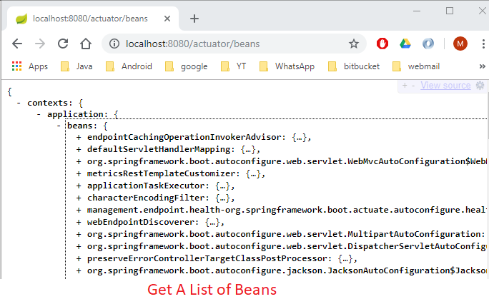

But what about security??? We will add security later.

**Development Process (Step-by-Step)**:

1. Edit pom.xml and add spring-boot-starter-acuator
2. View actuator endpoints for: /health and /info
3. Edit "**application.properties**" to customize /info

Spring Boot Actuator